Course Methods Year 12 test three 2022

Student name: ________________ Teacher name: ________________

Task type: Response

Time allowed for this task: _____40______ mins

Number of questions: ____6_______

Materials required: Upto 3 calculators/classpads allowed

Standard items: Pens (blue/black preferred), pencils (including coloured), sharpener, correction fluid/tape, eraser, ruler, highlighters

Special items: Drawing instruments, templates, one page of A4 notes doublesided

Marks available: ___43___ marks

Task weighting: _10___%

Formula sheet provided: Yes

Note: All part questions worth more than 2 marks require working to obtain full marks.

Q1 (3, 3 & 2 = 8 marks)
Consider the discrete random variable and the table of probabilities below.

 | 0 | 1 | 2 | 3 | 4
 | 0.2 |  | 0.3 |  | 0.25

- Given that the expected value of is 2.15, determine the values of .

Solution
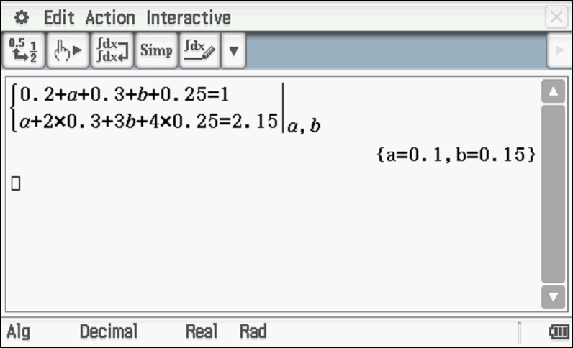

Specific behaviours
sets up one equation for a & b
sets up two equations for a&b
solves for a&b

- Determine the standard deviation of to 3 dp, showing all reasoning.

Solution
Specific behaviours
shows a sequence for variance
determines variance
determines std to 3 dp

- Determine the and Variance().

Solution
Variance().

Specific behaviours
determines new mean
determines new Variance

Q2 (3, 2, 1 & 3 = 9 marks)

The number of minutes late a train arrives at a particular station is a uniform probability distribution from 5 mins to 25 mins.
- Sketch the probability density function for showing all relevant features and labels.

Solution
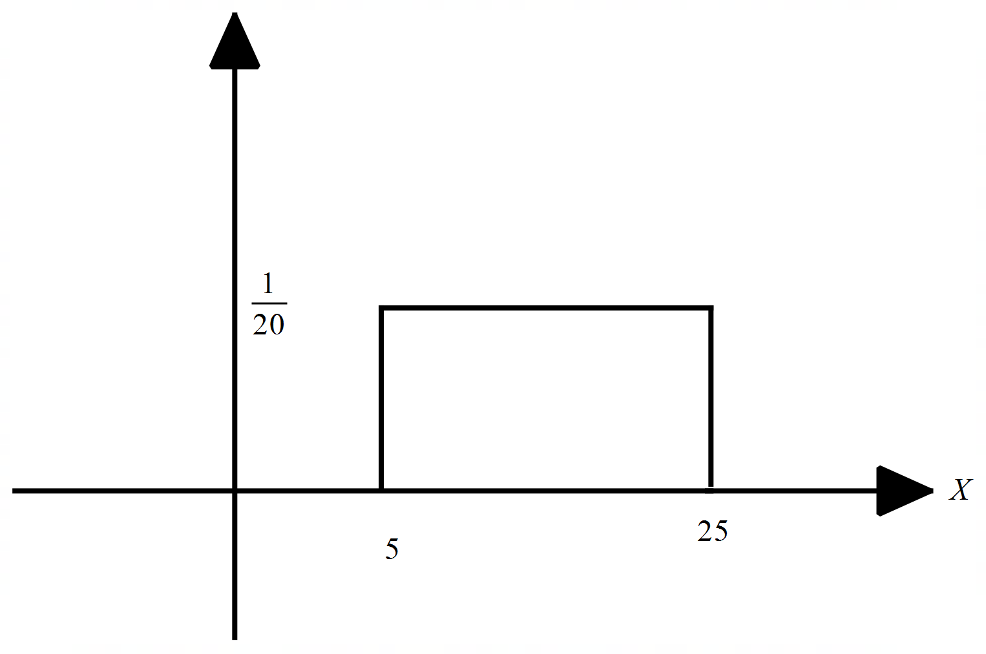

Specific behaviours
uses straight line
x labels
y label

Q2 continued
- Determine the probability that the train will be less than 12 mins late given that it is at least 7 mins late.

Solution
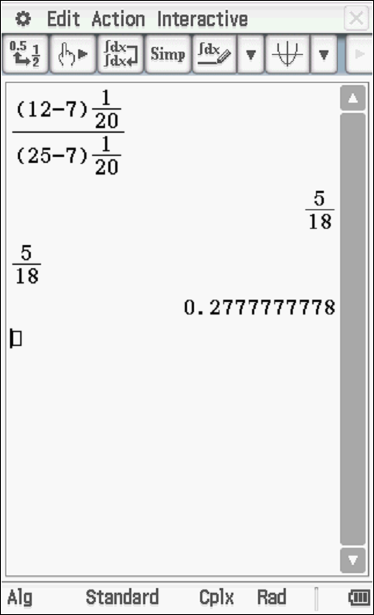

Specific behaviours
correct denominator
correct numerator

- Determine the mean number of minutes late.

Solution
Mean = 15 mins

Specific behaviours
states midpoint

- Determine the standard deviation of showing all reasoning.

Solution
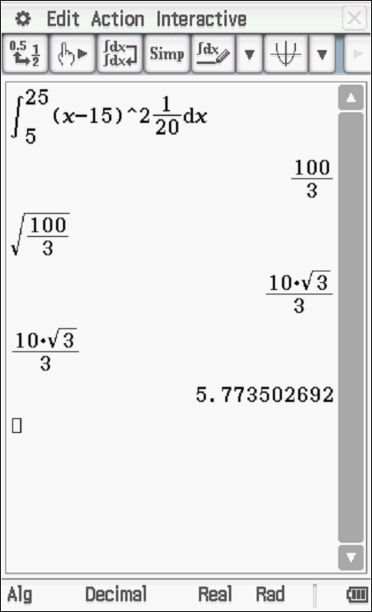

Specific behaviours
sets up integral
determines variance
determines stdev

Q3 (3, 3 & 2 = 8 marks)
Consider a game where two ordinary dice are thrown into the air and then land and the sum of the two top numbers is added. If the sum is a prime number etc then this is considered a win.

- Determine the probability of a win. Show reasoning.

Solution
 | 1 | 2 | 3 | 4 | 5 | 6
1 | 2 | 3 | 4 | 5 | 6 | 7
2 | 3 | 4 | 5 | 6 | 7 | 8
3 | 4 | 5 | 6 | 7 | 8 | 9
4 | 5 | 6 | 7 | 8 | 9 | 10
5 | 6 | 7 | 8 | 9 | 10 | 11
6 | 7 | 8 | 9 | 10 | 11 | 12
Prime numbers 2,3,5,7,11
Pr(prime)=15/36

Specific behaviours
shows sample space
number of favourable outcomes shown
states probability

- If this game was played 10 times, determine the probability that a win occurs at least 7 times. Show all reasoning.

Solution
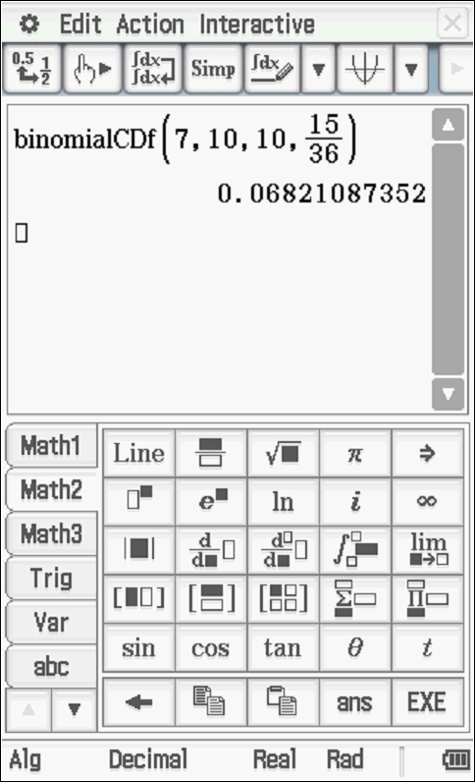

Specific behaviours
states Binomial with parameters
uses cumulative expression
states prob

- Let = sum of the top numbers of both dice. Determine the mean and standard deviation for .

Solution
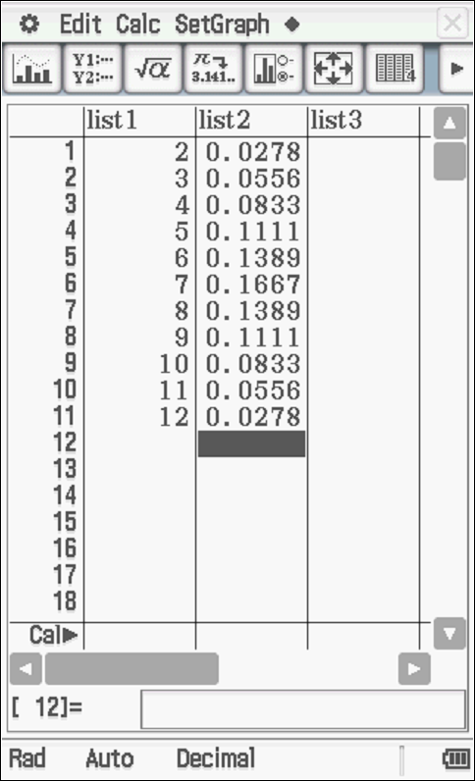
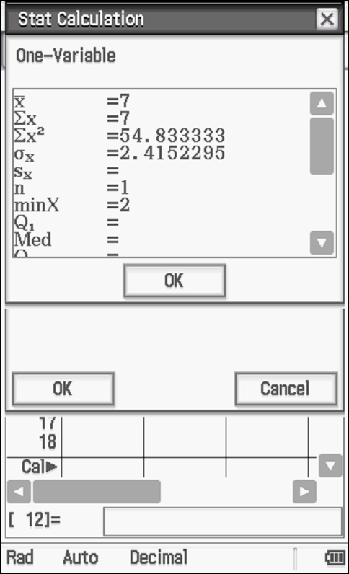

Specific behaviours
states mean of 7
states stdev 0f 2.415

Q4) (5 marks)
Consider where are constants.

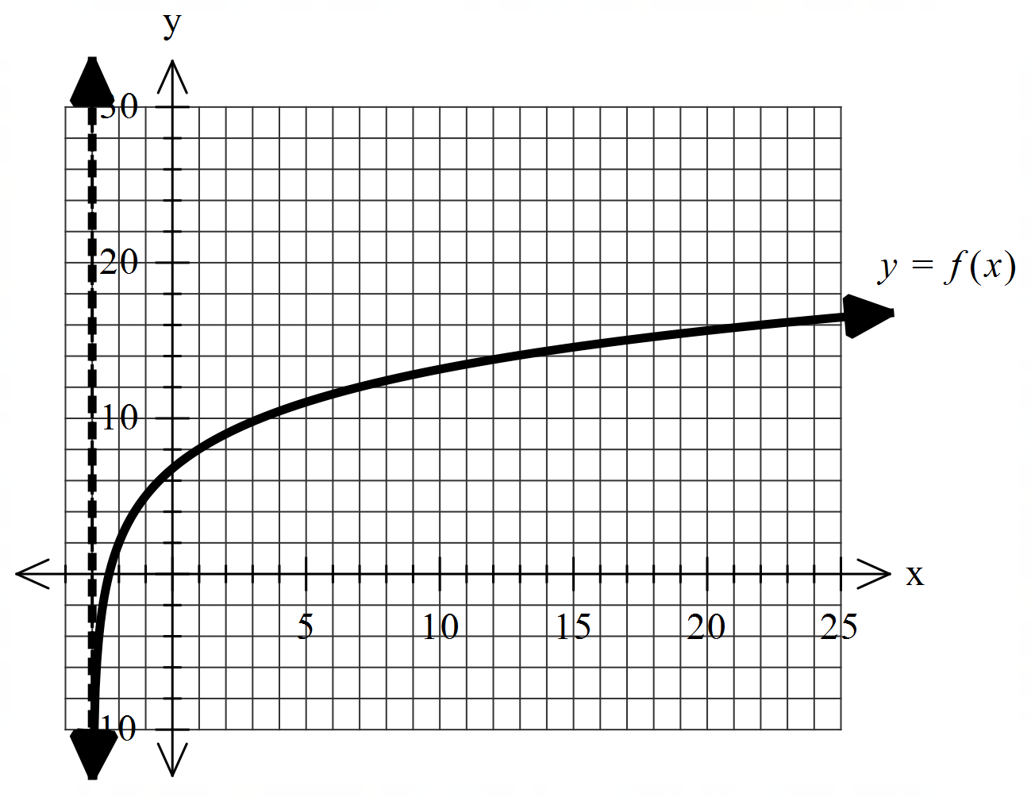

Using the graph above and given that the following points
lie on the curve , determine the values of .

Solution
Asymptote x=-3, p=3

Specific behaviours
identifies asymptote at x=-3
determines p
sets up one equation with two unknowns
sets up two equations with two unknowns
states r & q

Q5 (2, 2 & 2 = 6 marks)
Consider the probability density function and zero for all other values
of .
- Show that .
Solution
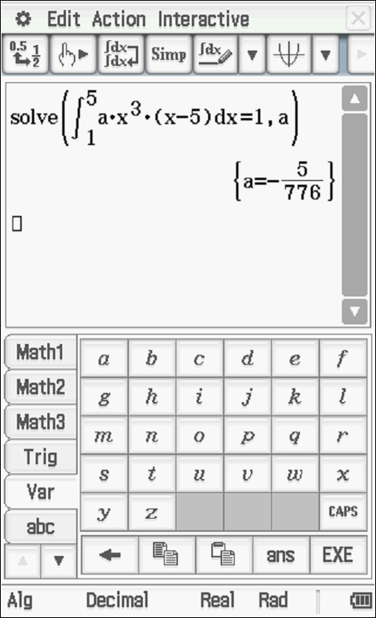

Specific behaviours
sets up integral for total area =1
shows equation to solve for a

- Determine the probability for the above function.

Solution

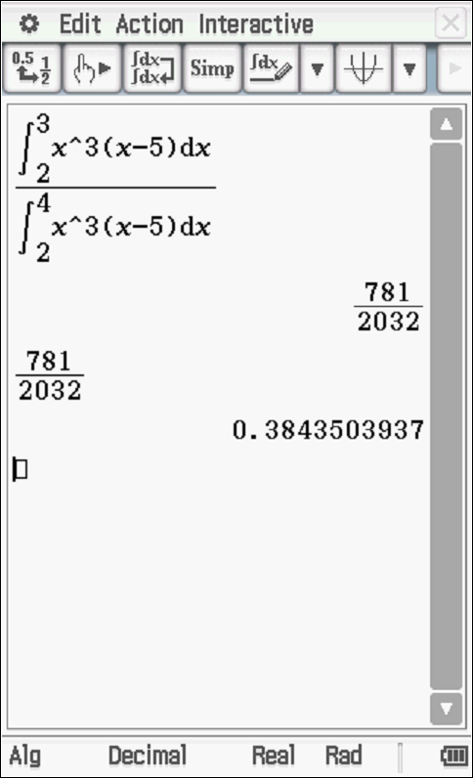
Specific behaviours
numerator
denominator

- Determine the median.

Solution
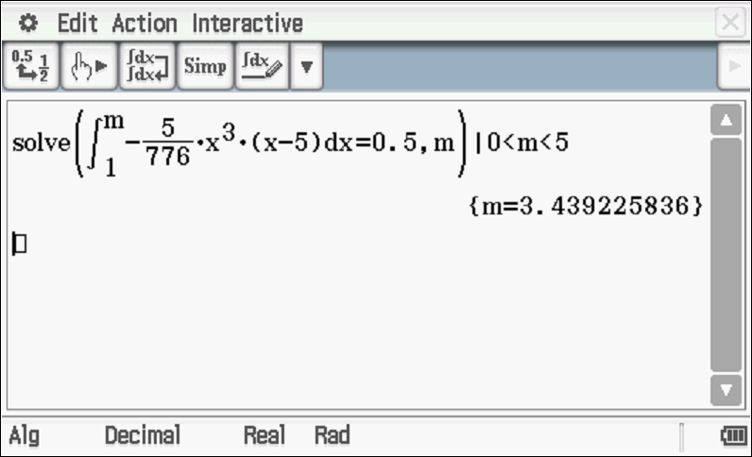

Specific behaviours
sets up equation for median
states one median only

Q6 (2 & 5 = 7 marks)

- Show without the use of a classpad how to .

Solution
Specific behaviours
uses product rule
obtains correct expression

- Using (a) above and without the use of a classpad, show how to evaluate .

Hint-use

Solution

Note- zero marks if answer given without any working!
Specific behaviours
integrates expression from part a
uses FTC
changes and shows integration of these two terms (or uses u=3x+1)du
evaluates x=0 and x=1 showing both values for two terms after integration
changes factor to give required definite integral(no need to simplify)

